INSTRUCTIONS ADMIN SIDE
1. Each administrator can customize the Home page title to display their assigned School Name or School ID. The Home dashboard is filtered to show only data for their assigned school, including: Present Today, Absent Today, Most Active This Month, Most Absent This Month, and Recent Attendance Logs.
Administrators can rename the Home page using their assigned School Name or School ID. The dashboard displays school-specific attendance information, including:
- Present Today
- Absent Today
- Most Active This Month
- Most Absent This Month
- Recent Attendance Logs
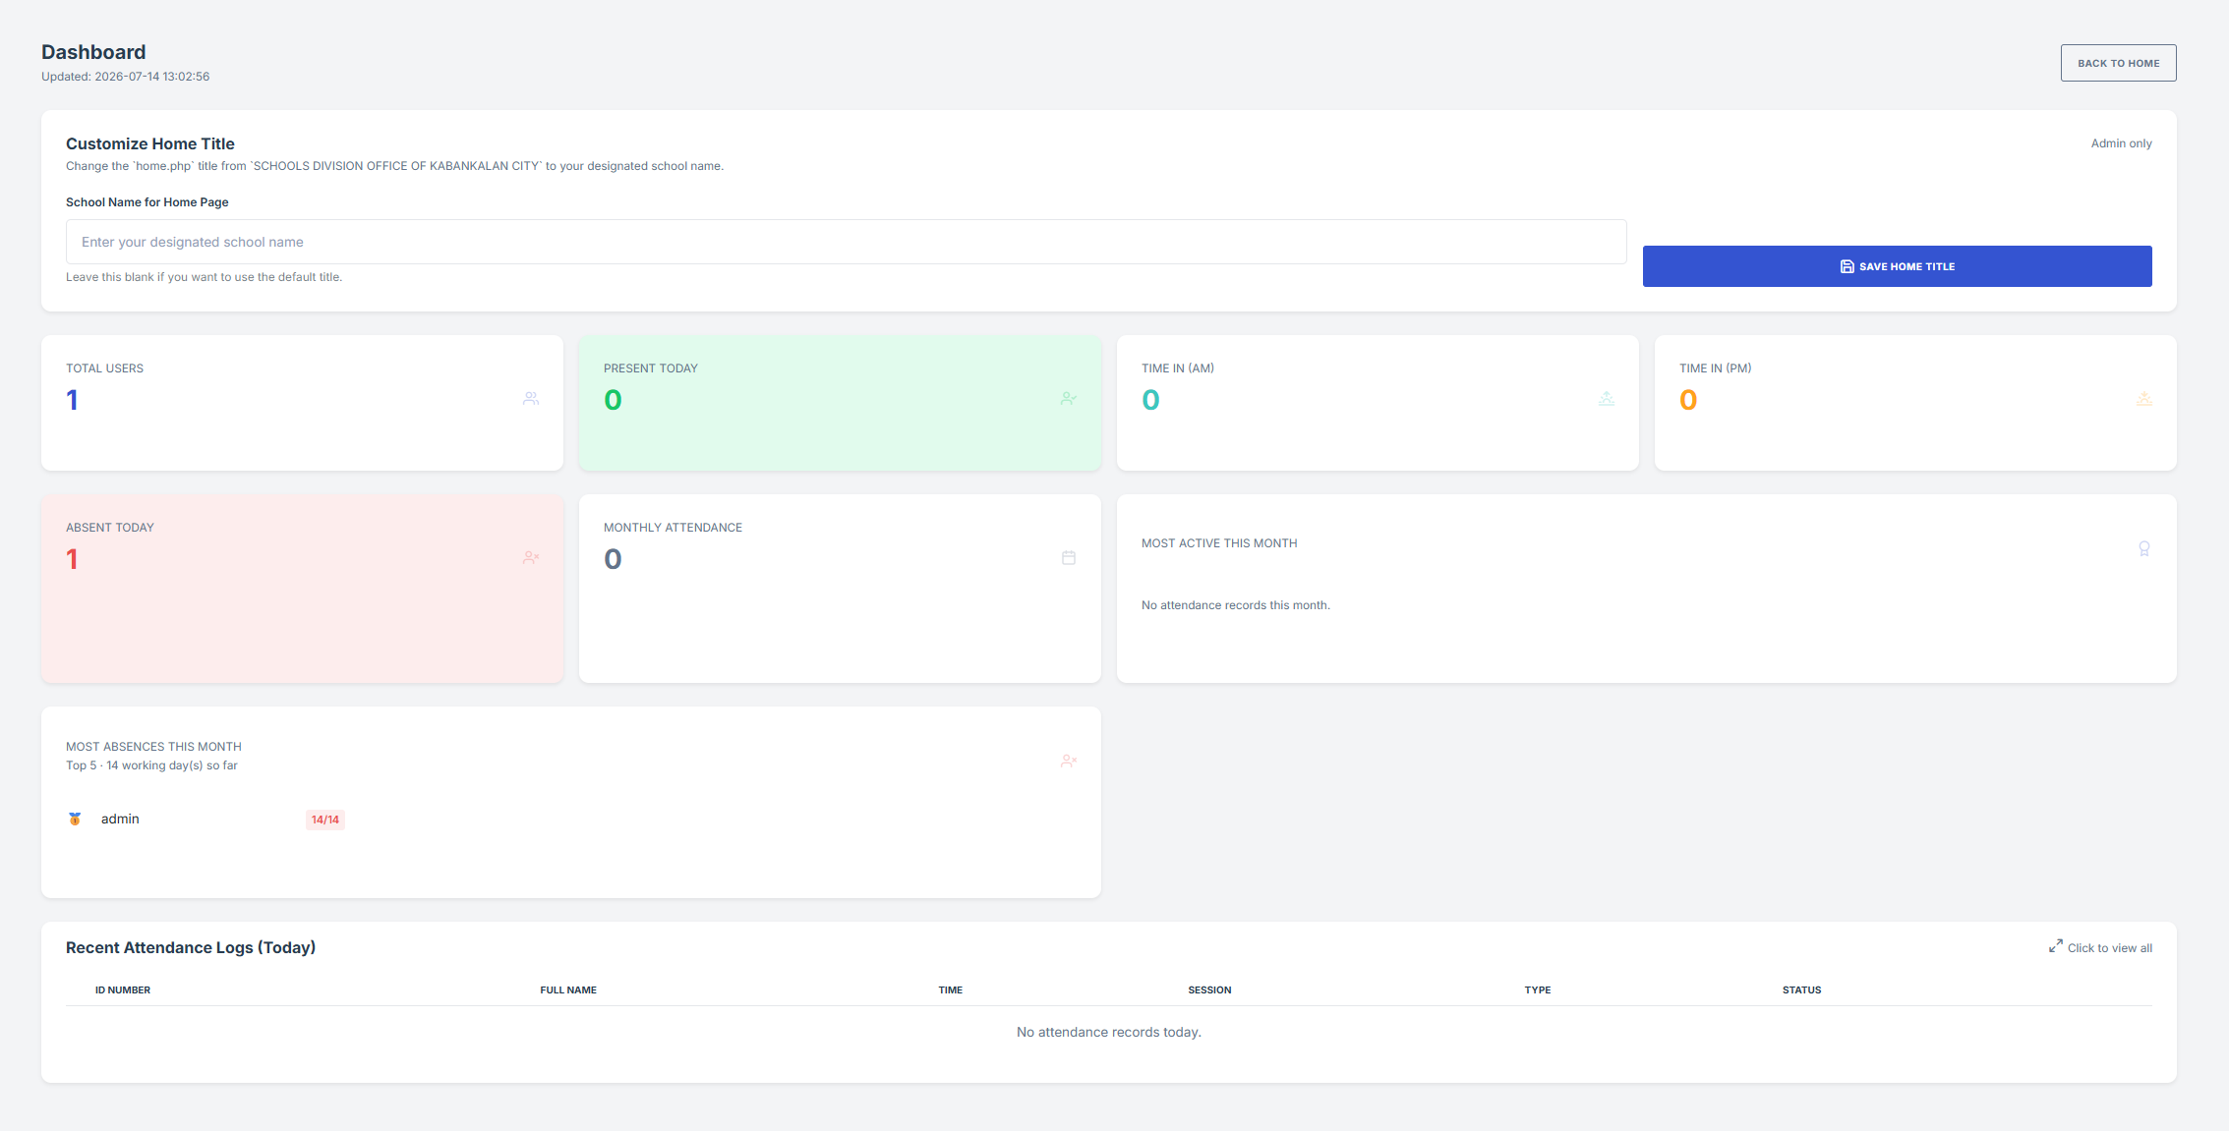
2. Attendance Monitoring
The Attendance Monitoring page displays real-time attendance records for the logged-in administrator's assigned school only. It provides a searchable and sortable table showing the User ID, QR Code ID, Full Name, Photo, Job Title, Date, Time In/Out (AM & PM), Attendance Status, and Actions. All attendance records are automatically updated after each successful QR code scan, ensuring administrators can monitor and manage attendance accurately while preventing access to records from other schools.
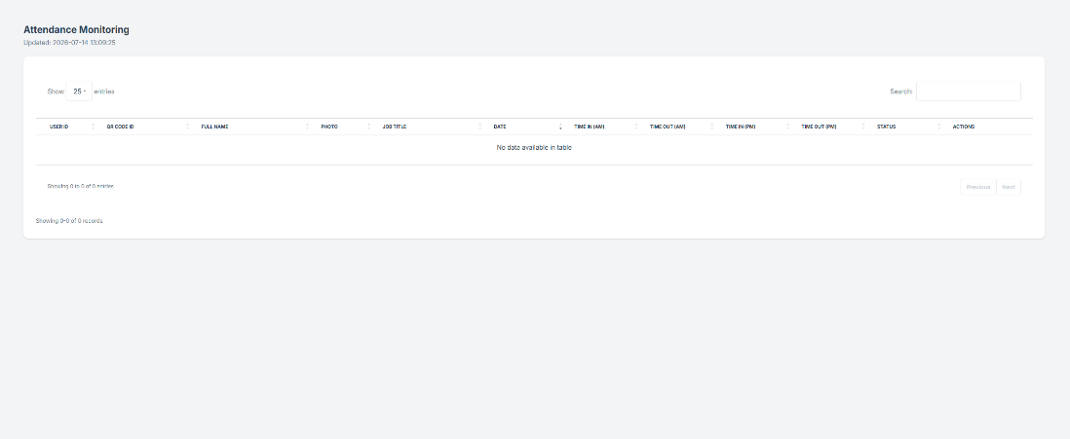

3. Daily Time Record (DTR)
The Daily Time Record (DTR) module allows administrators to search and select employees, specify a date range, and generate accurate, printable DTR reports. It supports viewing, printing, and downloading DTRs in PDF format while displaying only employees assigned to the administrator's school. Administrators can also customize the "In-charge" name before saving or generating the report.
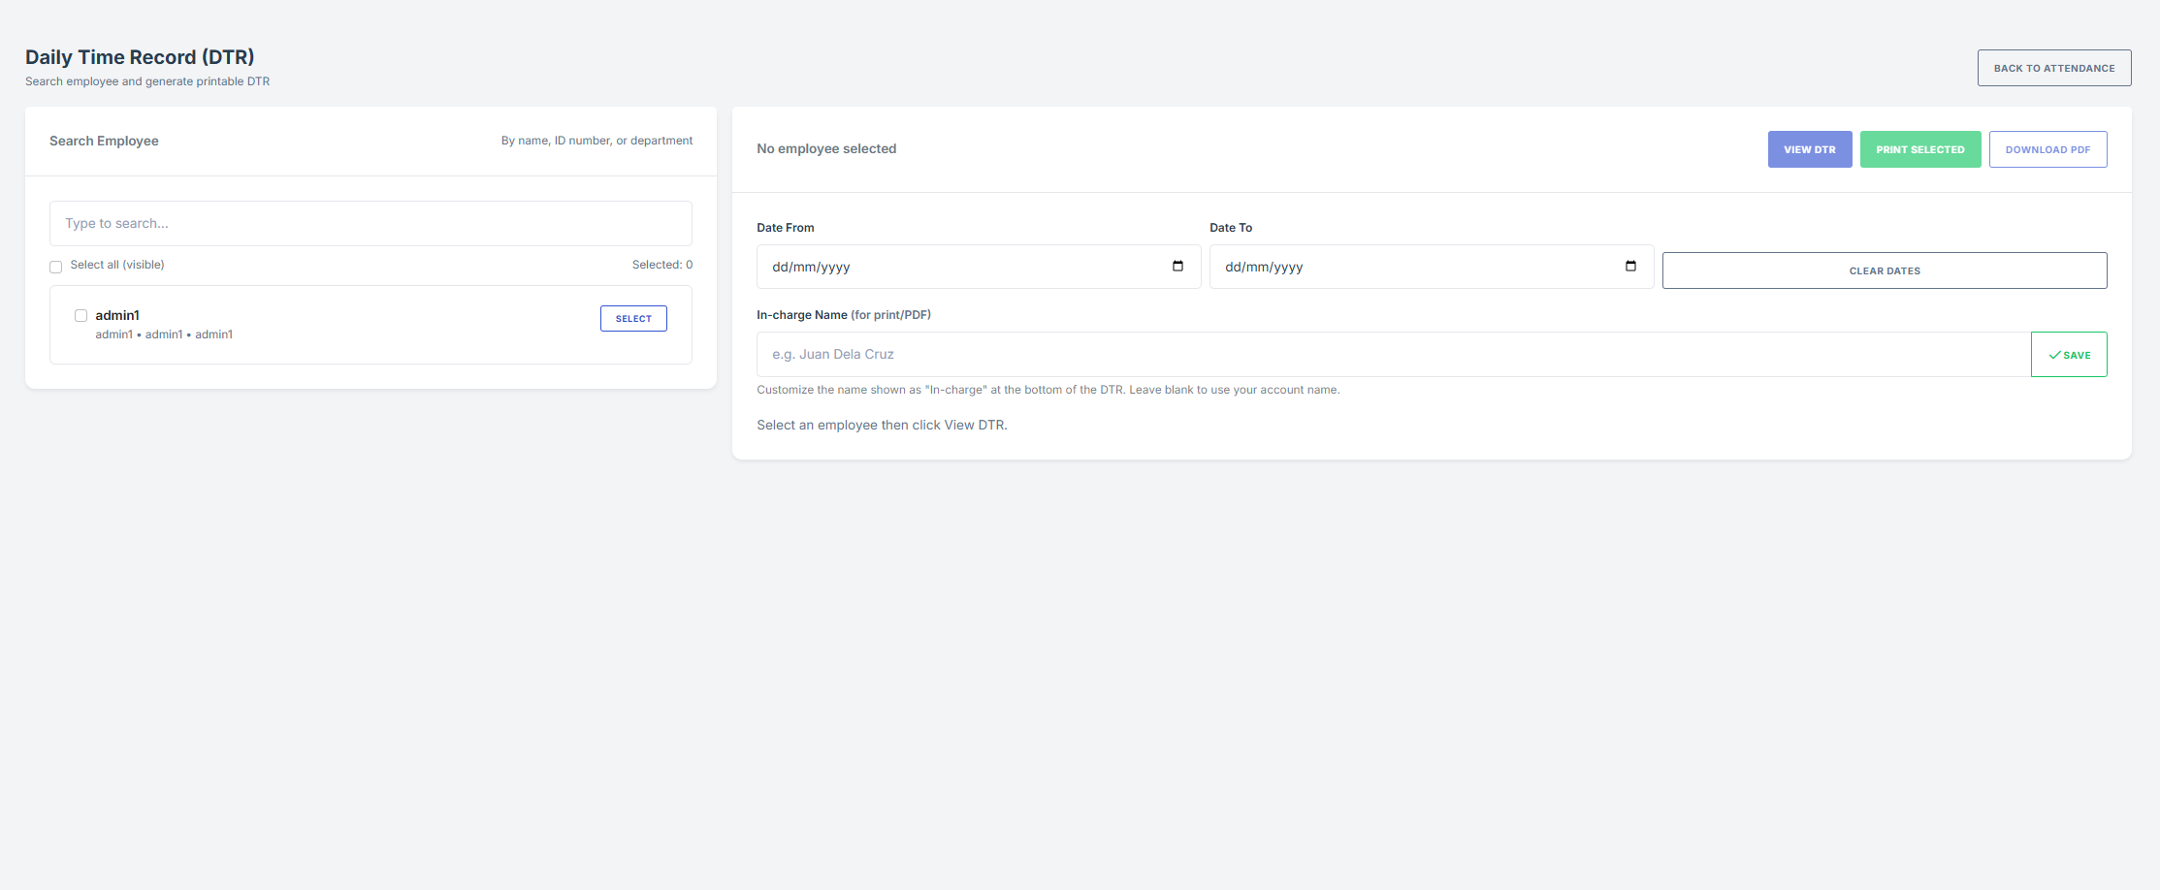
4. User Management
The User Management module allows administrators to create, update, and manage user accounts assigned to their school. It provides a searchable and sortable list of users with details such as Username, Real Name, ID Number, Role, Job, Department, and Status. Administrators can add, edit, delete, activate, generate QR codes, download ID templates, and import users using an Excel template, ensuring accurate and secure user management.
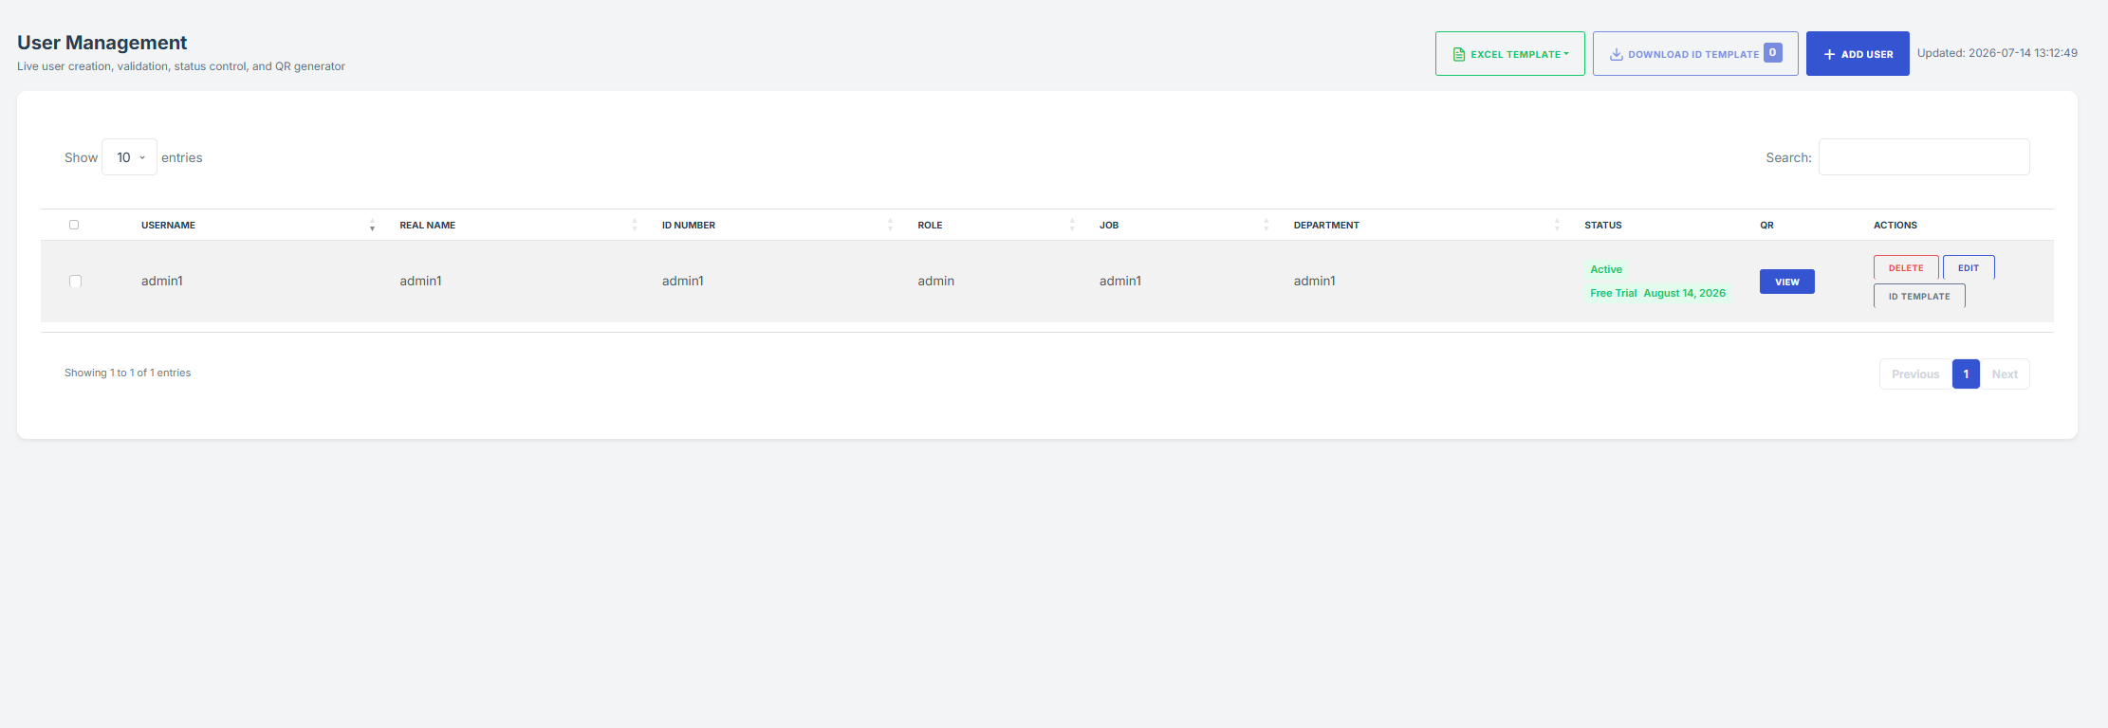

5. Home Page (QR Attendance Dashboard)
The Home page serves as the main attendance dashboard, allowing administrators to scan QR codes for real-time attendance recording. It displays the current date and time, live camera scanner, attendance logs, employee attendance details, and the latest recorded logs. Attendance is automatically recorded based on the assigned school, ensuring that only authorized users are monitored while preventing records from other schools from appearing on the dashboard.

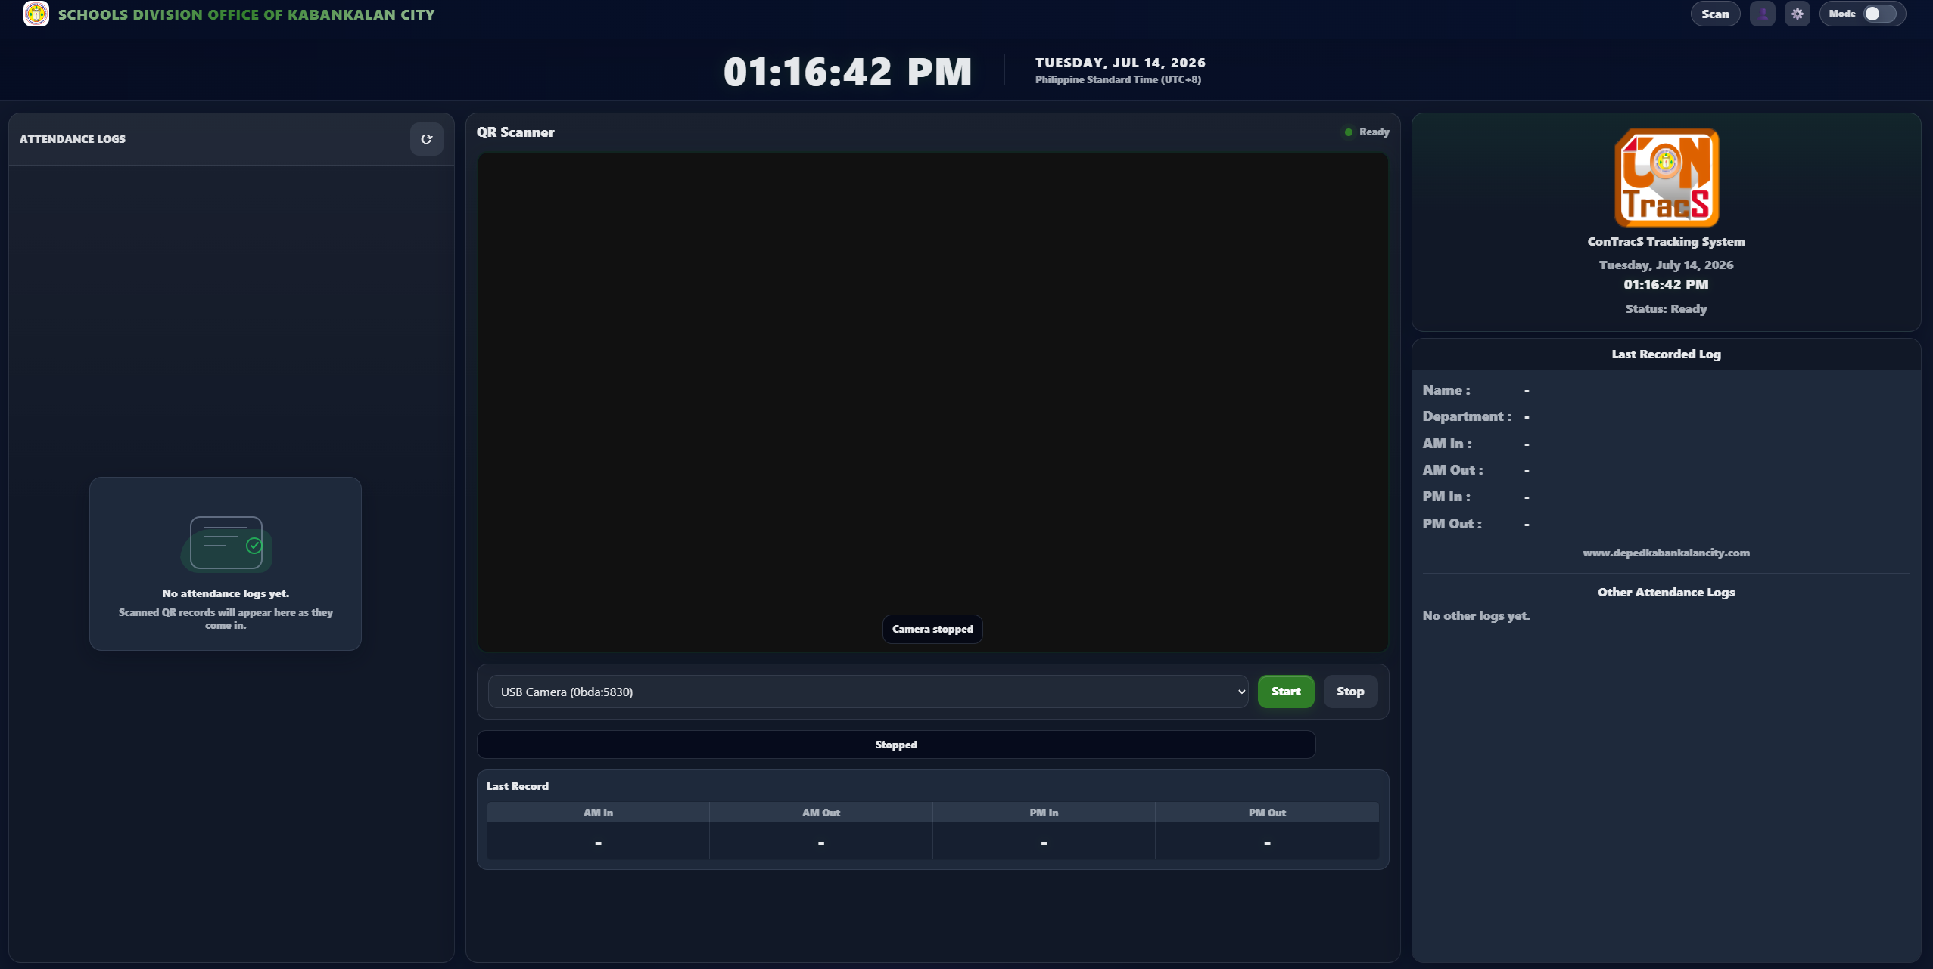

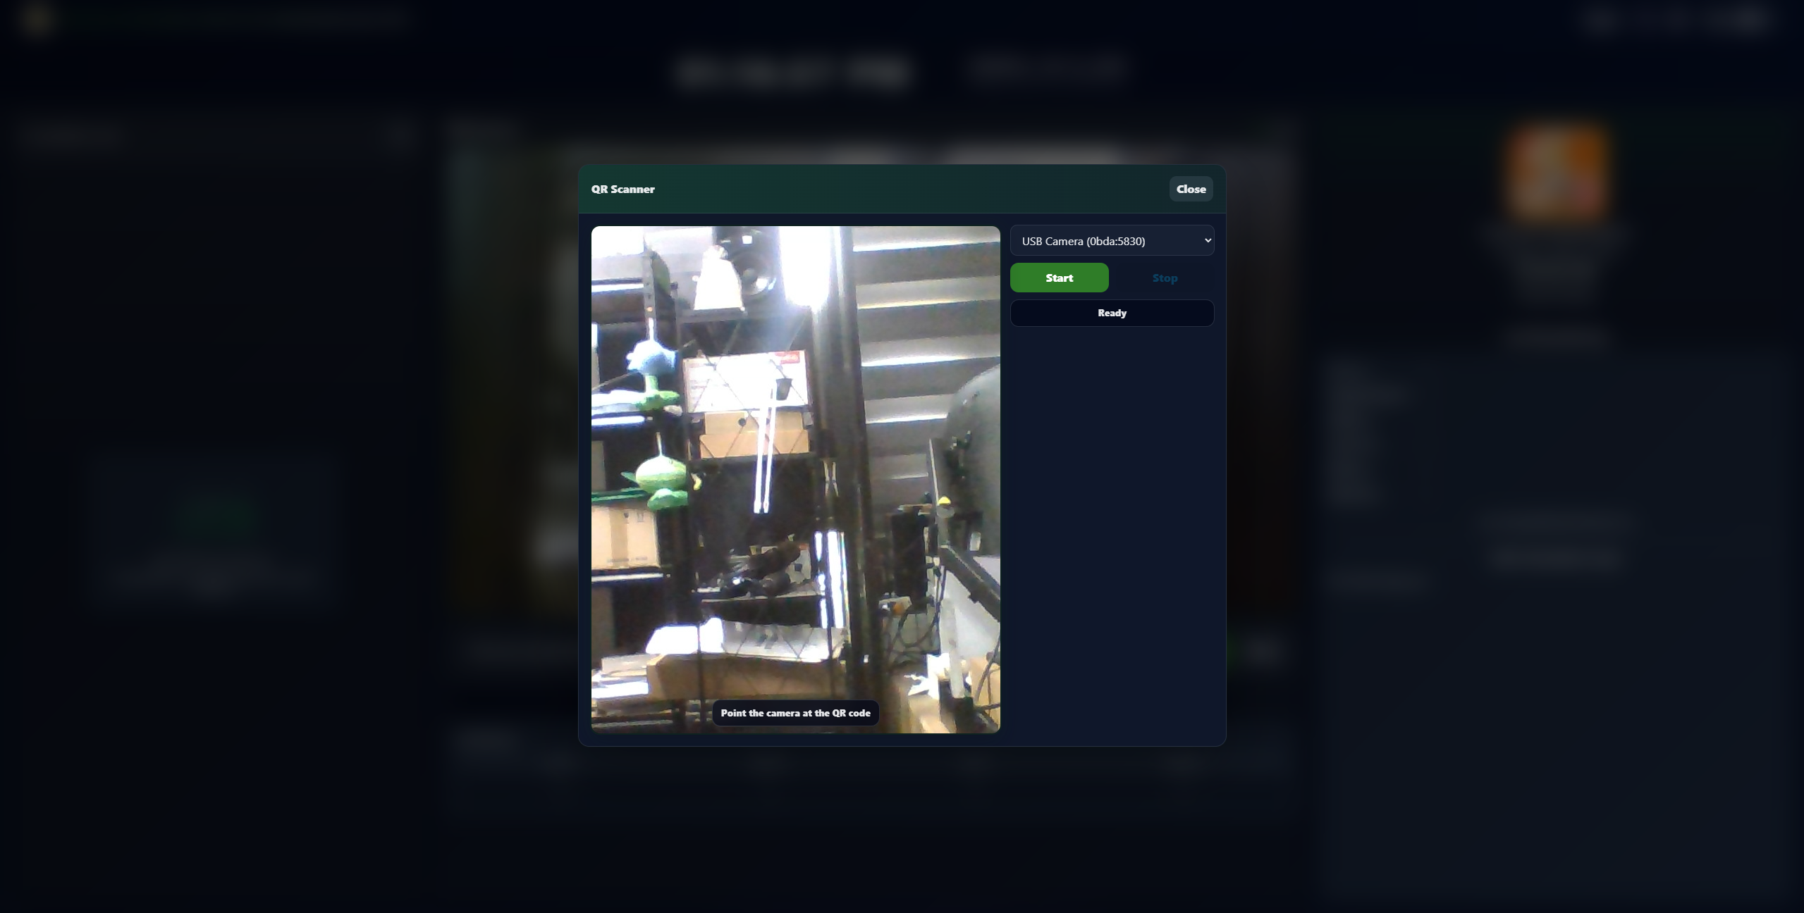

Topbar Instructions
Top Navigation Bar
The Top Navigation Bar provides quick access to essential system functions, including the sidebar menu, notifications, appearance settings, calendar, shortcuts, user profile, and account options. It enables administrators to navigate the system efficiently while accessing important features from any page.

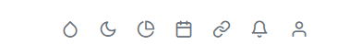
- Theme Color Customization
The Theme Color feature allows administrators to personalize the appearance of the Home page by selecting or entering a custom color. The selected theme is applied instantly across the dashboard interface and is saved automatically, ensuring the chosen color remains active on future logins for a consistent user experience.
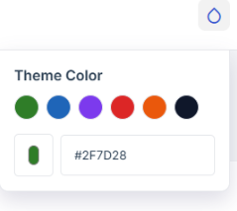
- Dark Mode Toggle
The Dark Mode Toggle allows administrators to switch between Light Mode and Dark Mode on the Home page. The selected appearance is applied instantly across the interface and is automatically saved, ensuring the preferred theme remains active during future sessions for a comfortable and consistent user experience
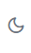

- Plan Usage

The Plan Usage feature allows administrators to monitor their subscription status and account limits. It displays the current plan, activation status, usage progress, remaining days, expiration date, and the number of users created. This helps administrators track their available resources and manage their account before the subscription expires.
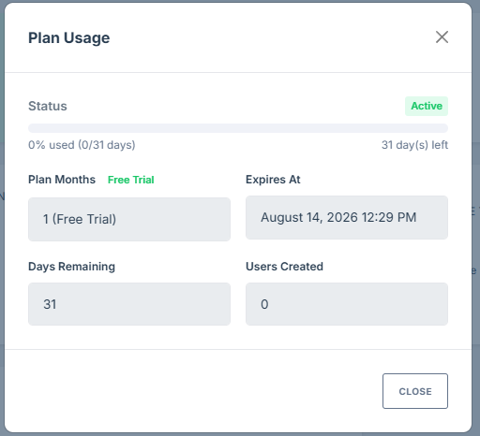

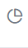

- Plan Extension Request
The Plan Extension Request feature allows administrators to extend their system subscription by selecting the desired number of months. It displays the total payment amount, a breakdown of system rent and maintenance fees, and an optional message field for additional requests before submitting the extension request.

GCash Payment
The GCash Payment feature enables administrators to pay for their plan extension by scanning the provided QR code or sending payment through the displayed GCash account details. After completing the payment, administrators can upload a proof of payment for verification and submit it for approval, ensuring a secure and efficient subscription renewal process.

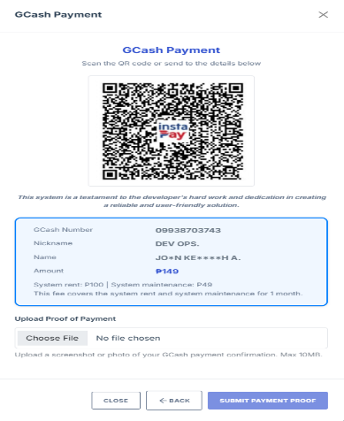
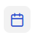
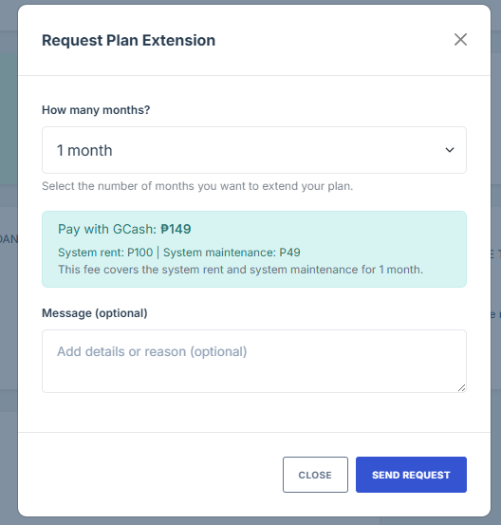

- Home Links Management
The Home Links Management feature allows administrators to manage and monitor their assigned Home page links for QR attendance. It displays the status of each link (Available or Locked), the number of devices in use, and the last access time. Administrators can copy and share available links, while locked links indicate they are currently active on another device, ensuring secure access and preventing unauthorized or simultaneous use.
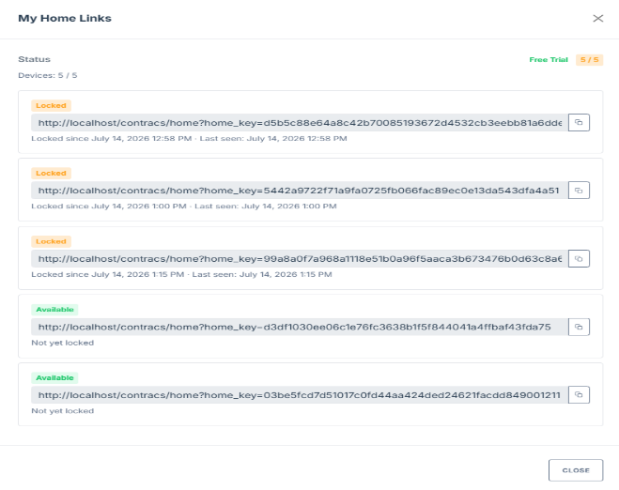

- Notifications
The Notifications feature keeps administrators informed of important system activities, including attendance updates, account changes, plan requests, and other system alerts. It provides real-time notifications to ensure timely awareness of important events.

User Profile
The User Profile feature allows administrators to view and manage their account information, including profile details, account settings, password updates, and secure logout. It provides quick access to personal account management while maintaining account security.

